Q1.

import matplotlib.pyplot as plt

x=['17/10','18/10','19/10','20/10','21/10','22/10','23/10','24/10','25/10']

y=[25,26,25.5,24,23.7,26.8,28,30.2,31]

plt.figure(figsize=(9,7))

plt.grid()

plt.xlabel("Date")

plt.ylabel("Temperature")

plt.plot(x,y,linewidth=0.5,linestyle='dotted')

plt.title("Date vs Temperature")

plt.show()

Output:

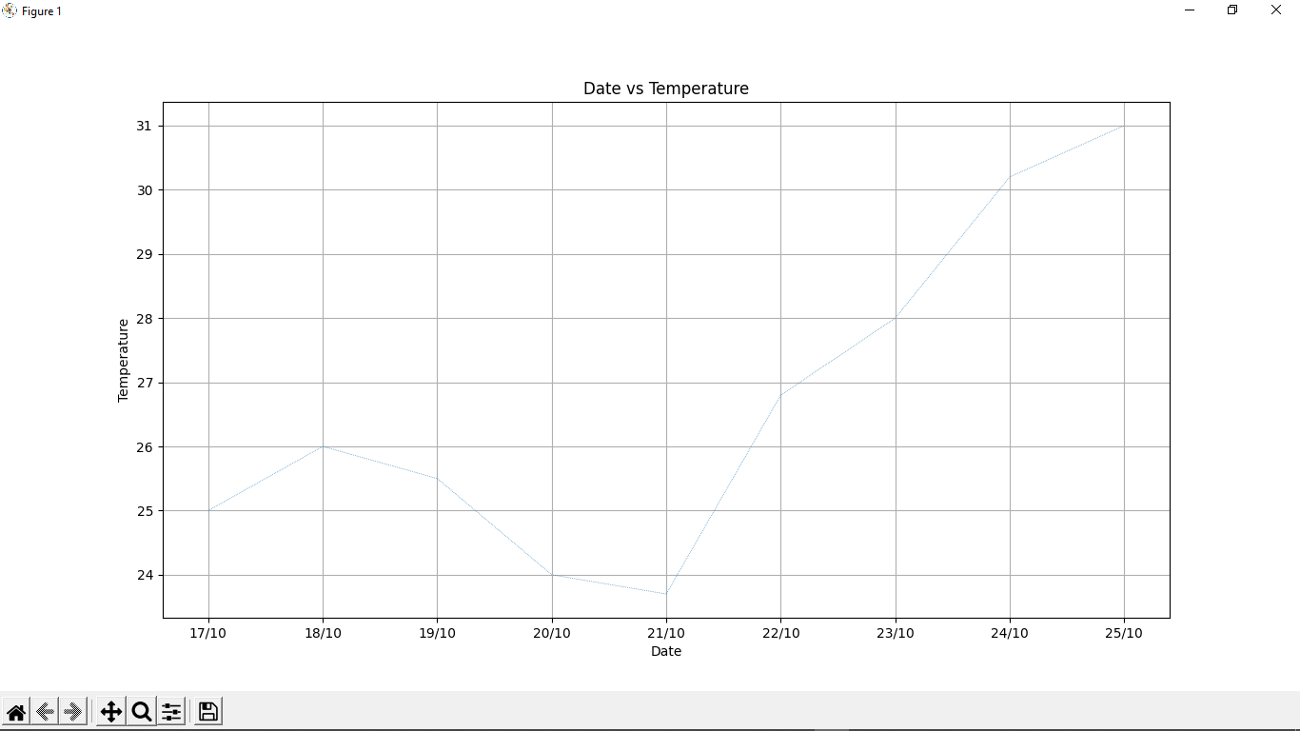

Q2.

import matplotlib.pyplot as plt

height = [121.9,124.5,129.5,134.6,139.7,147.3, 152.4, 157.5,162.6]

weight= [19.7,21.3,23.5,25.9,28.5,32.1,35.7,39.6, 43.2]

plt.xlabel("Weight in kg")

plt.ylabel("Height in cm")

plt.title("Average weight with respect to average height")

plt.plot(weight,height,color="green",marker="*",markersize=10,linestyle="dashed",linewidth=2)

plt.show()

Output:

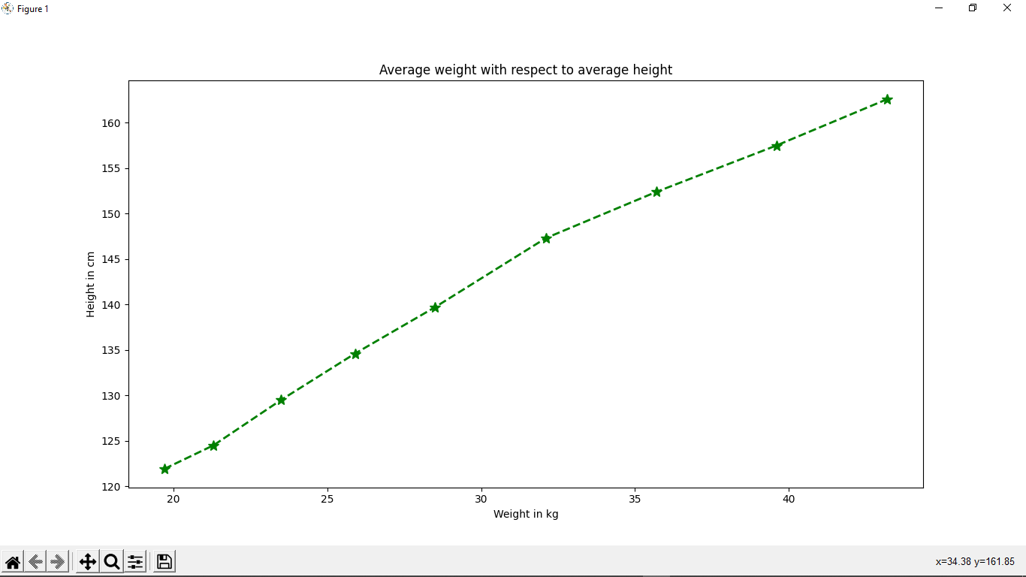

-----------------------------

Q3.

import matplotlib.pyplot as plt

week1=[7500,5500,6100,4500,5700,4000,6500]

week2=[6800,4700,5700,4800,5400,2700,5900]

week3=[7100,4500,4000,3700,4000,2200,6100]

weekday=['sunday','monday','tuesday','wednesday','thursday','friday','saturday']

weeks=[week1,week2,week3]

plt.figure(figsize=(10,20))

plt.bar(weekday,week1,color="red",edgecolor="black")

plt.bar(weekday,week2,color="blue",edgecolor="black")

plt.bar(weekday,week3,color="brown",edgecolor="black")

plt.title("Mela sales report")

plt.xlabel("Days")

plt.ylabel("Sales in Rs")

plt.show()

Output:

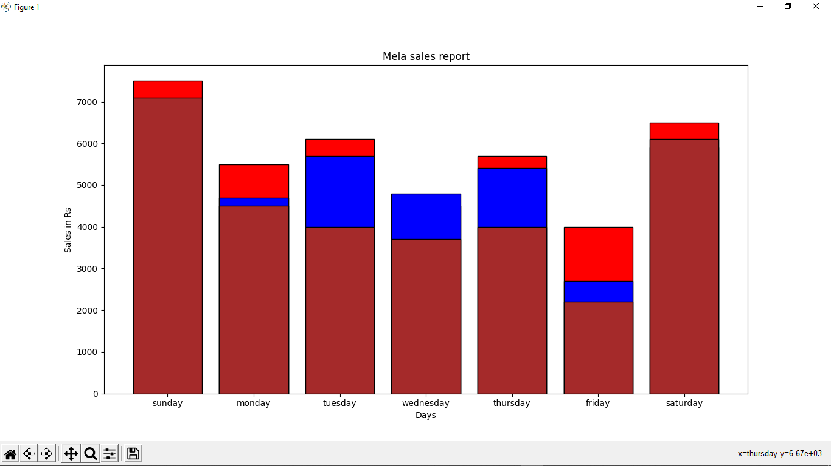

-----------------------------

Q4.

import matplotlib.pyplot as plt

ForestCover=[66964,28105,17346,17146,18186,12489,7726]

State=['Arunachal Pradesh','Assam','Manipur','Meghalaya','Mizoram','Nagaland','Tripura']

myexplode=[0,0,0,0,0.2,0,0]

plt.pie(ForestCover,labels=State,wedgeprops={"edgecolor":"black"},explode=myexplode,autopct='%1.1f%%')

plt.title("Forest Cover of north eastern states")

plt.legend(State,title="States",loc="upper left",bbox_to_anchor=(1,0,0,1))

plt.show()

Output:

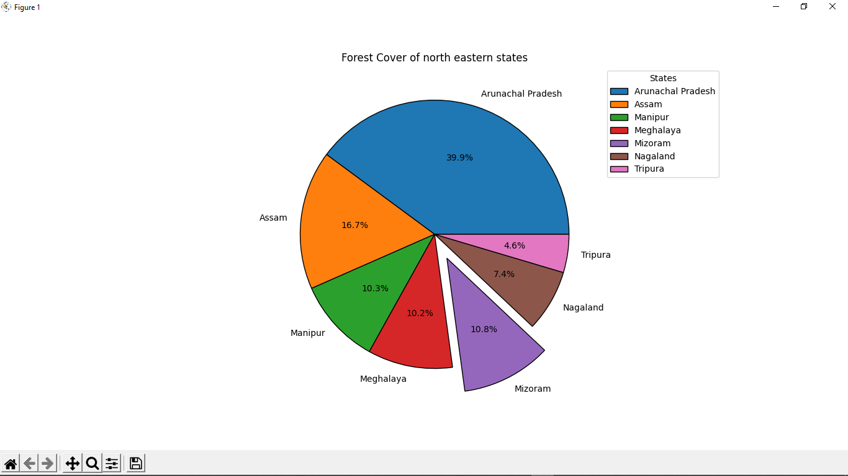

-----------------------------

Q5.

import matplotlib.pyplot as plt

import pandas as pd

df=pd.read_csv("E:\TYBCS\Python\College\Practice assignment 8\Min_Max_Seasonal_IMD_2017.csv")

# print(df)

x=df['ANNUAL - MAX']

y=df['JAN-FEB - MIN']

z=df['JAN-FEB - MAX']

plt.hist(x,edgecolor='black',width=0.3,color="purple",label="Annual-MAX")

plt.hist(y,edgecolor='black',width=0.3,color="orange",label="JAN-FEB - MIN")

plt.hist(z,edgecolor='black',width=0.3,color="blue",label="JAN-FEB - MAX")

plt.xlabel("Temperature")

plt.ylabel("No of Days")

plt.legend()

plt.title("No of days vs Temperature")

plt.show()

Output:

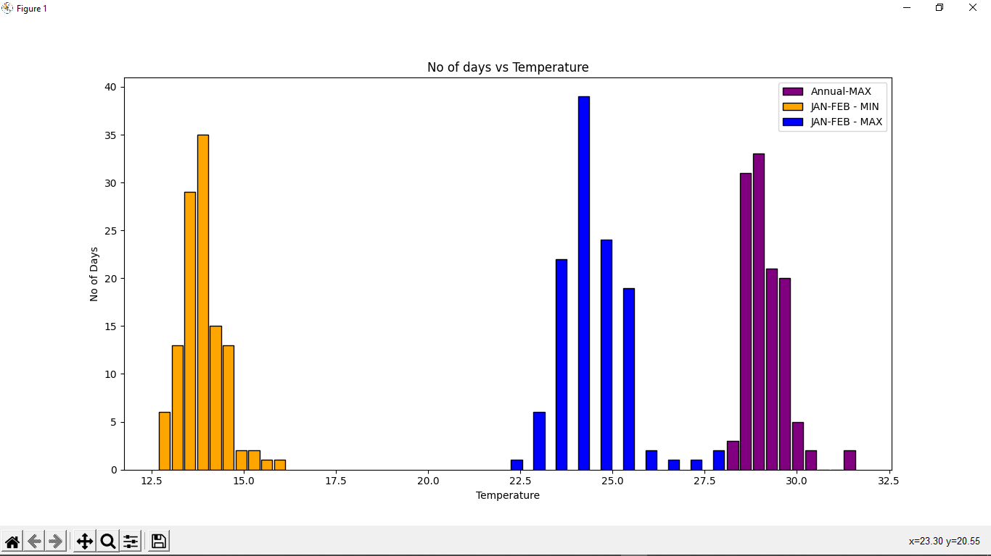

-----------------------------

Q6.

import matplotlib.pyplot as plt

dc = [10, 20, 30, 40, 50]

sales = [55000, 65000, 75000, 85000, 125000]

mycolors=['blue','hotpink','orange','green','red']

plt.scatter(dc,sales,marker="*",color=mycolors)

plt.title("Sales vs Discount")

plt.xlabel("Discount in percentage")

plt.ylabel("Sales in Rs.")

plt.show()

Output:

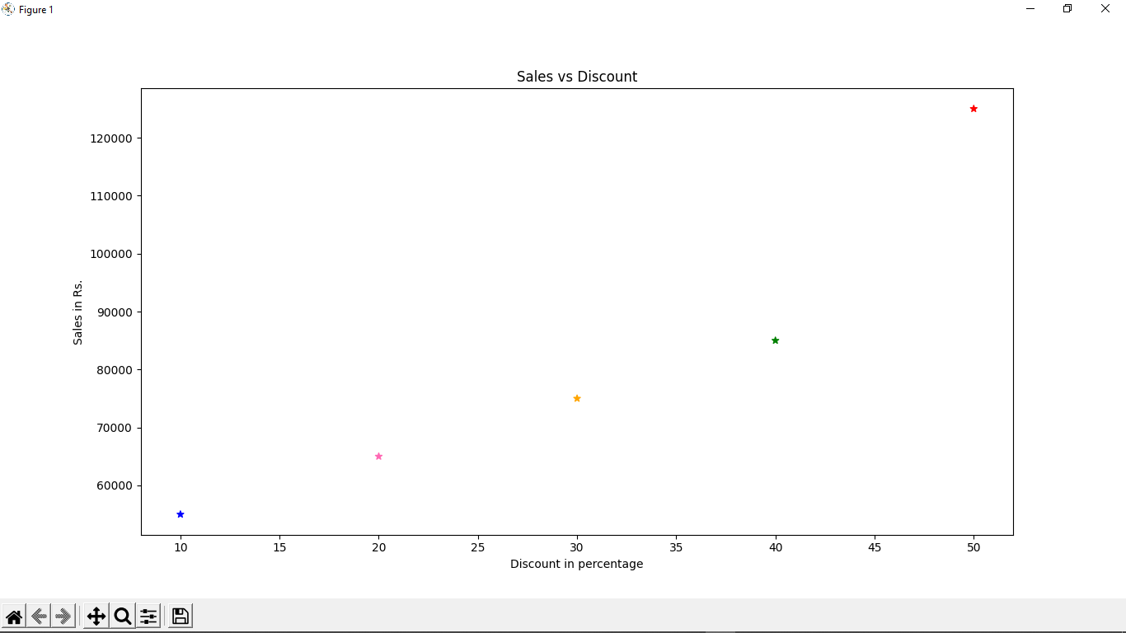

-----------------------------

Q7.

import matplotlib.pyplot as plt

import pandas as pd

df=pd.read_csv("E:\TYBCS\Python\College\Practice assignment 8\insurance.csv")

x=df['bmi']

y=df['charges']

plt.scatter(x,y)

plt.xlabel("BMI")

plt.ylabel("Charges")

plt.title("BMI vs Charges Scatter plot")

plt.show()

print(df['region'].value_counts())

x=[364,325,325,324]

lb=['southeast','northwest','southwest','northeast']

plt.pie(x,labels=lb,shadow=True,autopct='%1.1f%%')

plt.legend(loc="upper left",bbox_to_anchor=(1,0,0,1))

plt.show()

x=df['bmi']

plt.hist(x,width=1.5,color='red')

plt.title('BMI')

plt.xlabel('BMI')

plt.show()

x=df['children']

plt.hist(x,width=0.4,color='blue')

plt.title('Children')

plt.xlabel('Children')

plt.show()

x=df['age']

plt.hist(x,width=1.5,color='green')

plt.title('Age')

plt.xlabel('Age')

plt.show()

x=df['charges']

plt.hist(x,width=5000,color='orange')

plt.title('Charges')

plt.xlabel('Charges')

plt.show()

Output:



